Step 1
- I backed up the bootcamp database with pg_dump -Fc and checked it with pg_restore --list.
- I restored it into bootcamp_check and both databases had the same row count, so the backup is valid."
On Windows I used %USERPROFILE%\backups instead of ~/backups.

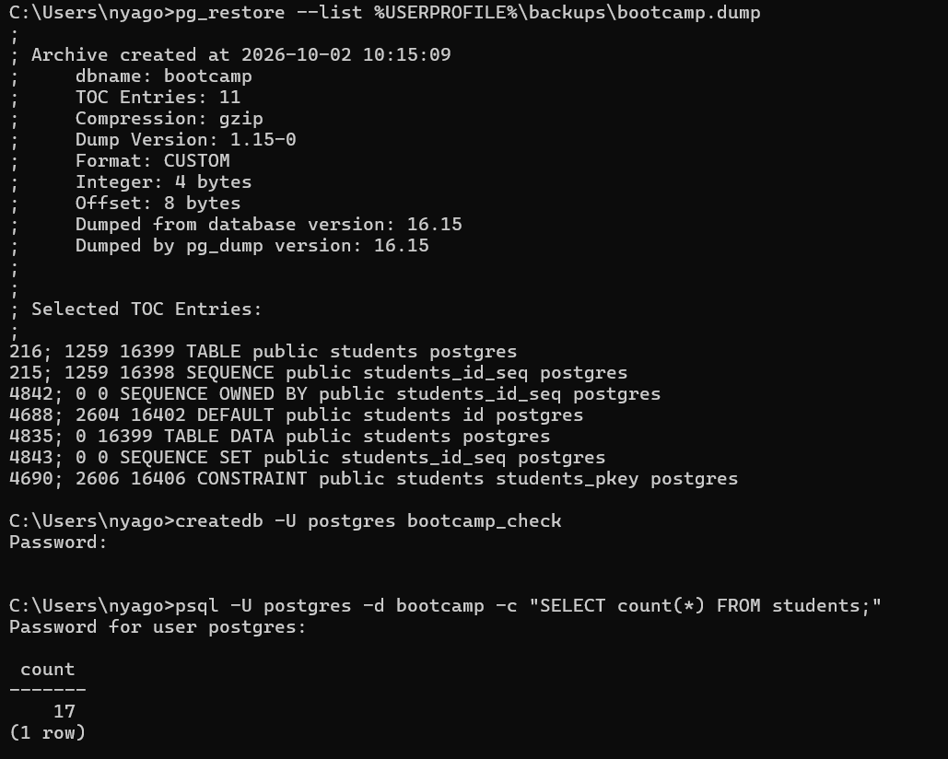

STEP 2
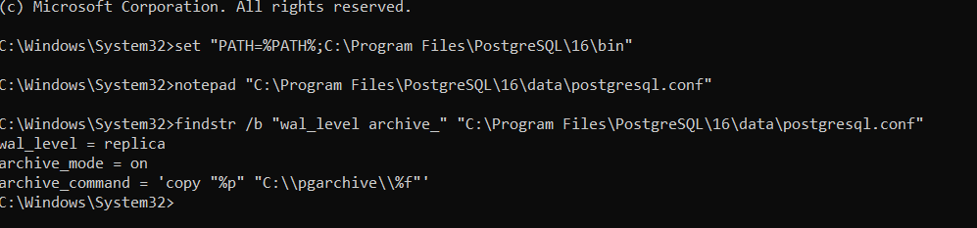
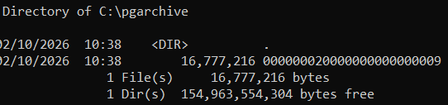
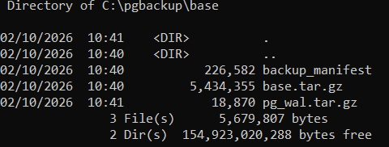
- I enabled WAL archiving with wal_level = replica, archive_mode = on and an archive_command that copies WAL files to C:\pgarchive. I restarted PostgreSQL, forced a WAL switch to confirm files were archived, then took a base backup with pg_basebackup.
On Windows, cp became copy and the paths became C:\pgarchive and C:\pgbackup, because PostgreSQL runs as a Windows service and has no ~ or sudo systemctl.
STEP 3
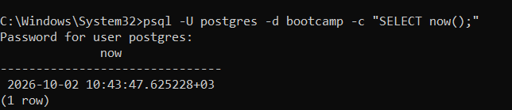
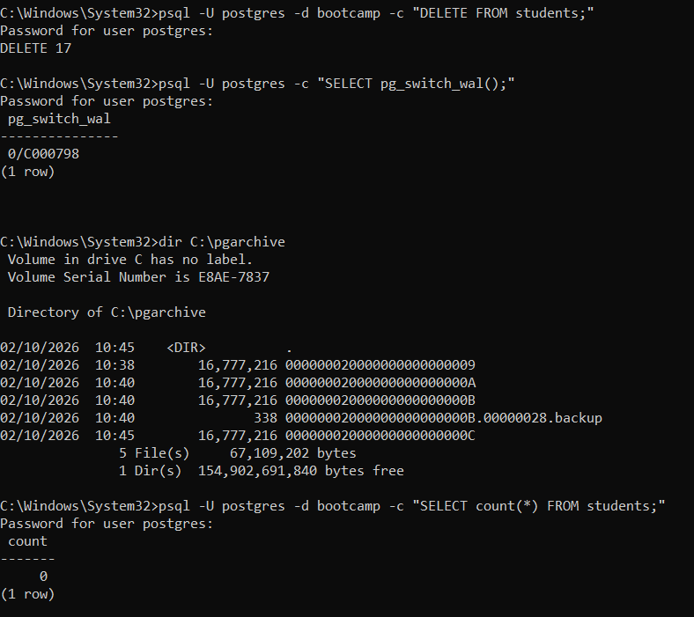
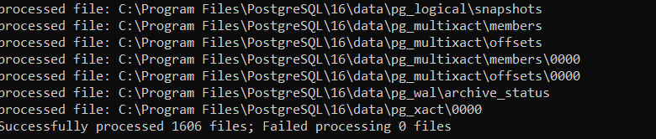

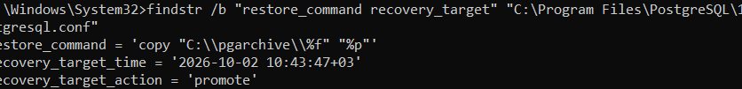

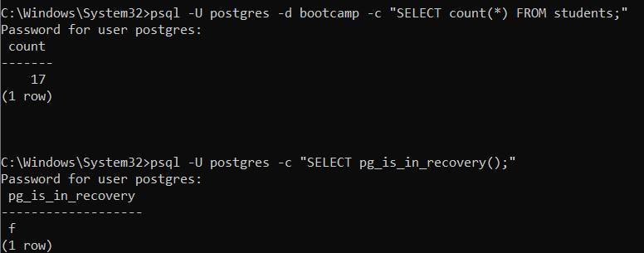
I recorded 2026-10-02 10:43:47+03, deleted all 17 rows (DELETE 17), forced a WAL switch, and confirmed the count was 0. I then stopped PostgreSQL, moved the old data folder to data_old, and extracted the base backup into a new data folder.
I added restore_command, recovery_target_time = '2026-10-02 10:43:47+03' and recovery_target_action = 'promote', created recovery.signal, and started PostgreSQL. It replayed the archived WAL up to that time. The count returned to 17 and pg_is_in_recovery was false, so the point-in-time recovery worked."
PostgreSQL 12+ needs a recovery.signal file to start recovery, and I used recovery_target_action = 'promote' so the server opens for writes at the target.
STEP 4
I created the replicator role with REPLICATION LOGIN, built the standby with pg_basebackup -R into C:\standby, removed the inherited recovery settings, set port = 5433, and started it as a service. pg_is_in_recovery returned true.
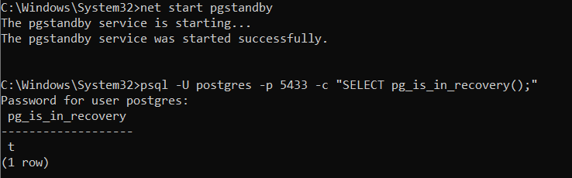

STEP 5
pg_stat_replication showed walreceiver in the streaming state with a lag of 0 bytes, and a row inserted on the primary appeared on the standby.
No pg_hba.conf edit was needed because the Windows installer already allows replication from 127.0.0.1. The standby runs on port 5433 because it shares the machine with the primary

